Creation of PipeLine

1. Select pipeline and click on release  
   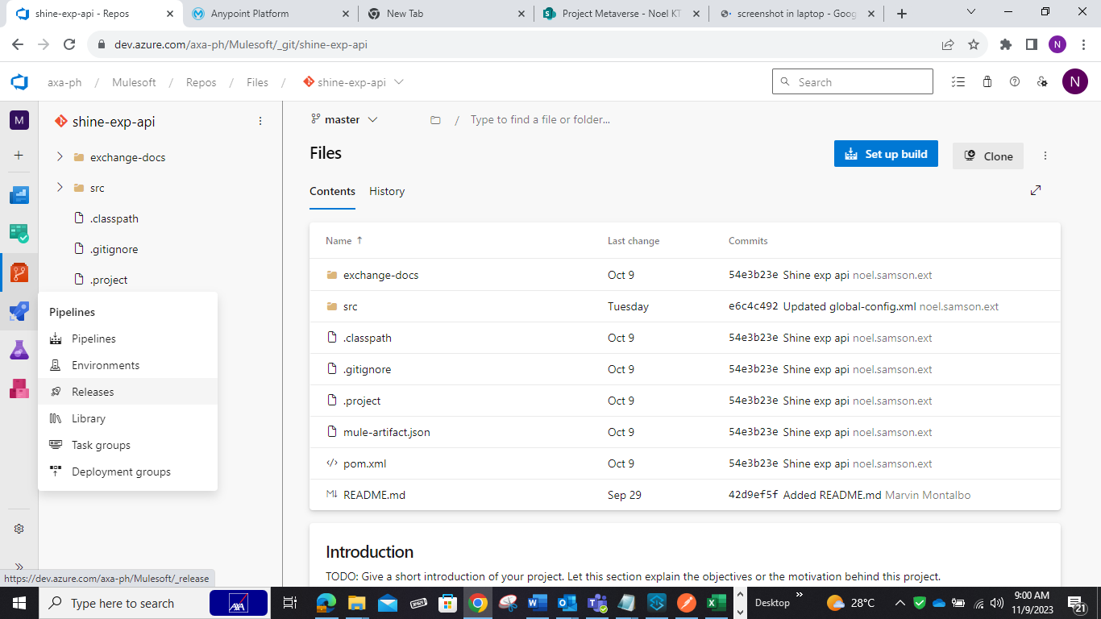
2. Add atifacts  
   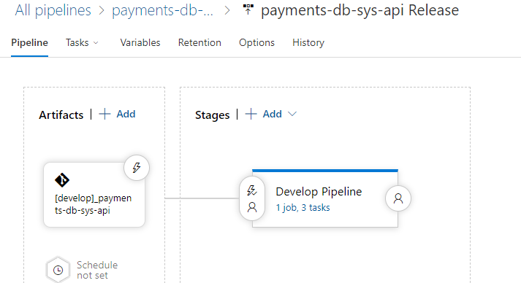
3. Populate the following :  
   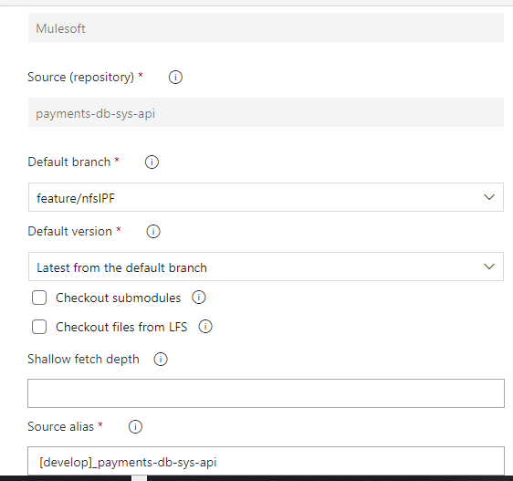
4. From develop pipeline create the following :  
   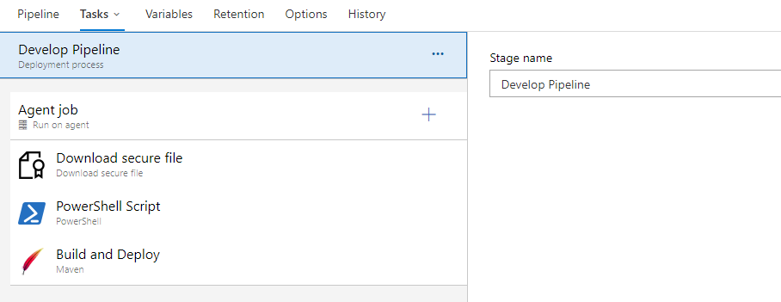
5. From download secure file fill out the following :  
   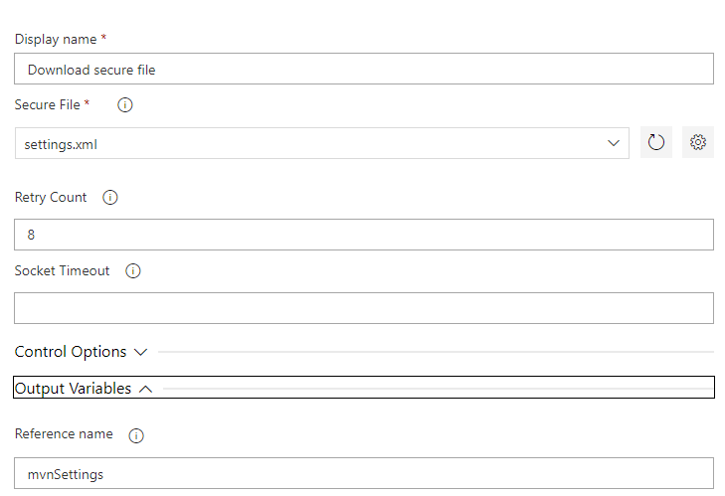
6. From powershell fill out the following :  
   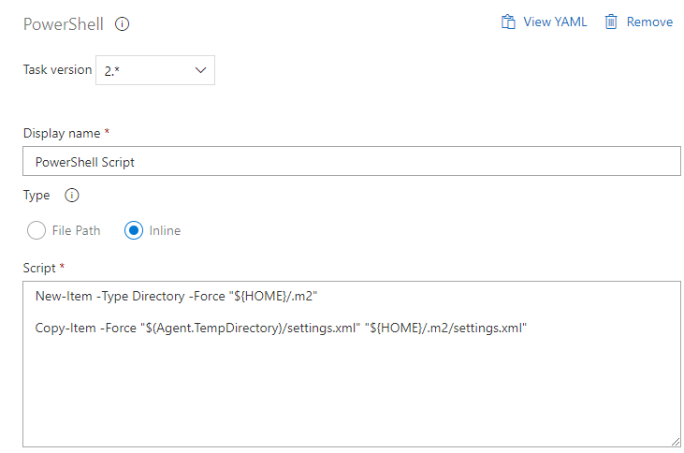
7. From maven fill out the following ;  
   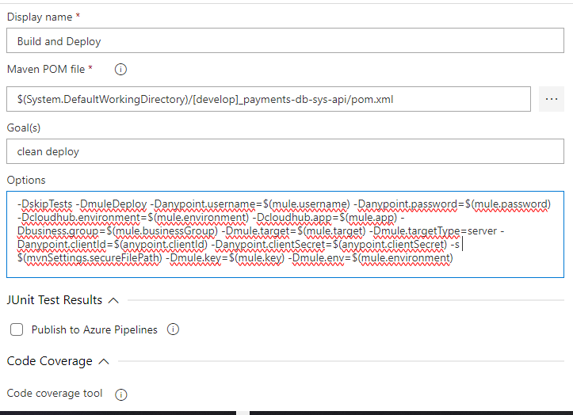  
   option value:  
   -DskipTests -DmuleDeploy -Danypoint.username=$(mule.username) -Danypoint.password=$(mule.password) -Dcloudhub.environment=$(mule.environment) -Dcloudhub.app=$(mule.app) -Dbusiness.group=$(mule.businessGroup) -Dmule.target=$(mule.target) -Dmule.targetType=server -Danypoint.clientId=$(anypoint.clientId) -Danypoint.clientSecret=$(anypoint.clientSecret) -s $(mvnSettings.secureFilePath) -Dmule.key=$(mule.key) -Dmule.env=$(mule.environment)
8. From variable add this:  
   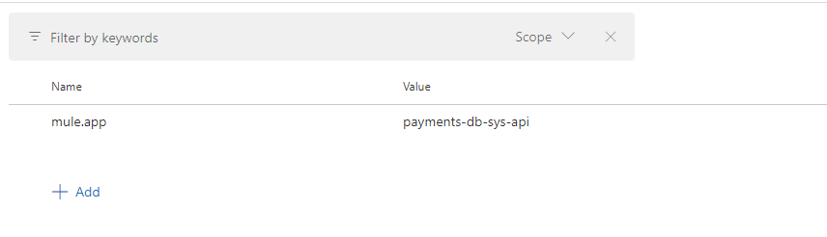
9. From variable group link this:  
   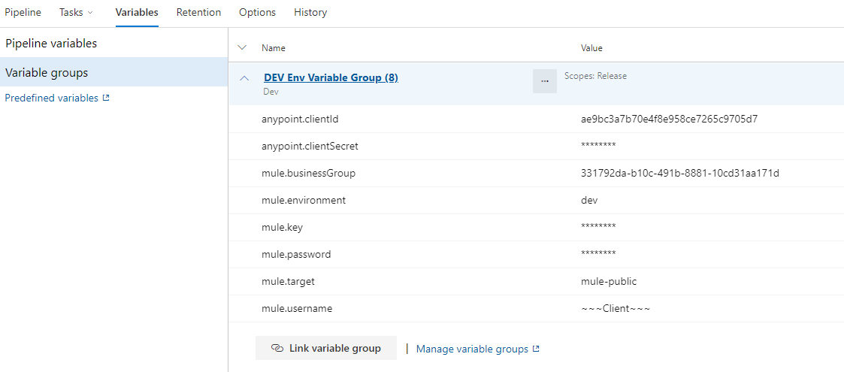

How to Create Link Variables:

1. from link variables create the following:  
   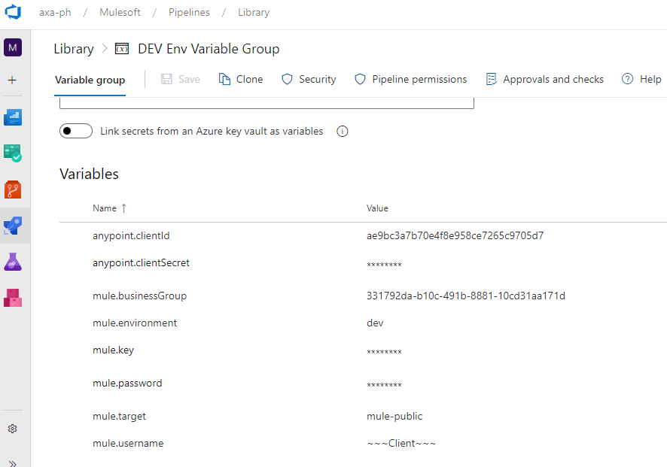

how to create secure file, setting.xml  
1. Create here:

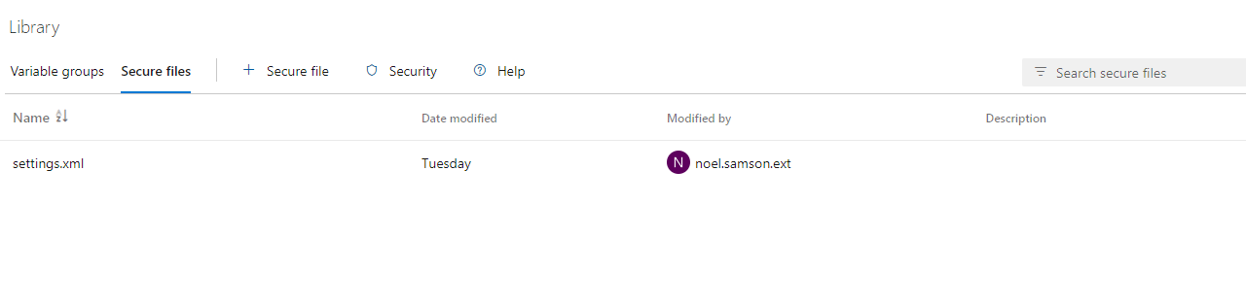

How to create personal token:

